The final version (I) of your Thesis have to be submitted to the Dean’s Office at least a week before the defence date. It means that Students who defend:
- June 30th – have to submit before June 22th
- June 14th or 19th – have to submit before June 30th
If you will not be able to meet this deadline (June 30th), please apply for extension (file attached)
From the date of full submission of your Thesis you will have 30 days for the defence.
In case you apply for the extension the period of extension can be up to August 30th.

I.
(final version)
DEAN’S OFFICE
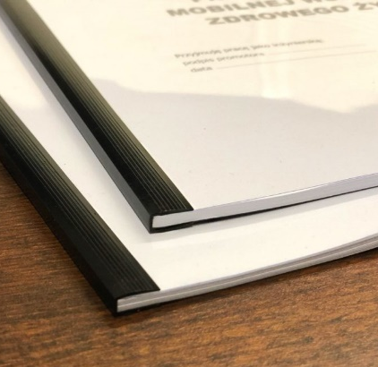
- printed two-sided (!)
- soft cover (!)
- without the foil in front (!)
+ F4 Form
+ F5 Form
(!) double-check Thesis title if identical as in Thesis form
To be checked by Dean’s Office (offhand)

if positive then you can proceed:
- Supervisor is checking thesis in Plagiarism System
- Supervisor or Student will submit the thesis with certificate from Plagiarism System to the Dean’s Office
- Dean’s Office give you a Review Form
II.
for
REVIEWER
- default: hard cover
- any colour
- one or two-sided (ask your supervisor)
+ Review Form (from Dean’s Office)
+ Have to be stamped by (a) your Supervisor, (b) your Department stamp, (c) Dean’s Office stamp.

To be submitted to the Reviewer (remember to ask about the Article assigned by the Reviewer)
The Review will be available for you at least 3 days before the defence date in the Dean’s Office.
III.
for
SUPERVISOR
- default: hard cover (ask your supervisor)
- any colour
- one or two-sided (ask your supervisor)

+ Have to be stamped by (a) your Supervisor, (b) your Department stamp, (c) Dean’s Office stamp.

This is a copy for your Supervisor:)
After the defence (when you’ll have a Graduate status in the Virtual Dean’s Office) you are supposed to submit it to the University Repository (file named: University Repository of Diploma Theses at the website: https://wtd.up.poznan.pl/en/masters_courses/wood_science )

F4 form

Declaration of the author of the diploma thesis regarding its original nature, sole authorship and non-infringement of copyrights

…………………………………………………
full name of the student

…………………………………………………
record book No.

I hereby declare to have delivered a diploma thesis titled

....................................................................................................................................................

....................................................................................................................................................

which is my own work. I therefore further declare:
- not to have had a third party write the thesis or any part thereof,
- not to have copied the thesis or any part thereof from other works and papers thematically connected therewith,
- to have solely relied on necessary consultations,
- that if authored by other parties, any and all components used in the preparation of my thesis (quotations, figures, tables, programs etc.) were adequately marked, and the source thereof was specified,
- my thesis has not been previously used as a basis for awarding a professional title or a university diploma neither to me nor to anyone else.

I am aware that if my statement is false, I will not be admitted to the diploma exam, or the decision to award the diploma will be reversed and a disciplinary procedure will be initiated.

......................................................
date and legible signature of the author

F5 form

Author’s declaration of consistency
between the electronic and hardcopy version of his/her thesis

…………………………………………………
full name of the student

…………………………………………………
record book No.

I hereby declare that the hardcopy version of my diploma thesis, as enclosed hereto, titled

……………………………………………………………………………………………………………

……………………………………………………………………………………………………………

is consistent with the electronic version which, in the form of a file, was verified with the Unified Plagiarism Checker System and was uploaded to my account at the Virtual Dean’s Office.

......................................................
date and legible signature of the author

Considering the substantive contribution by the promoter.

